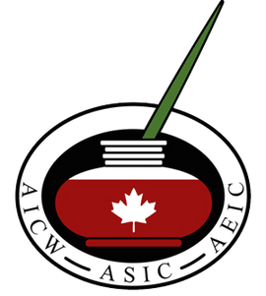

Common Ground, Distant Shores: Interdisciplinary Voices in Italian-Canadian and Italian Cultural Expressions

20th Biennial Conference
of the Association of Italian-Canadian Writers (AICW)

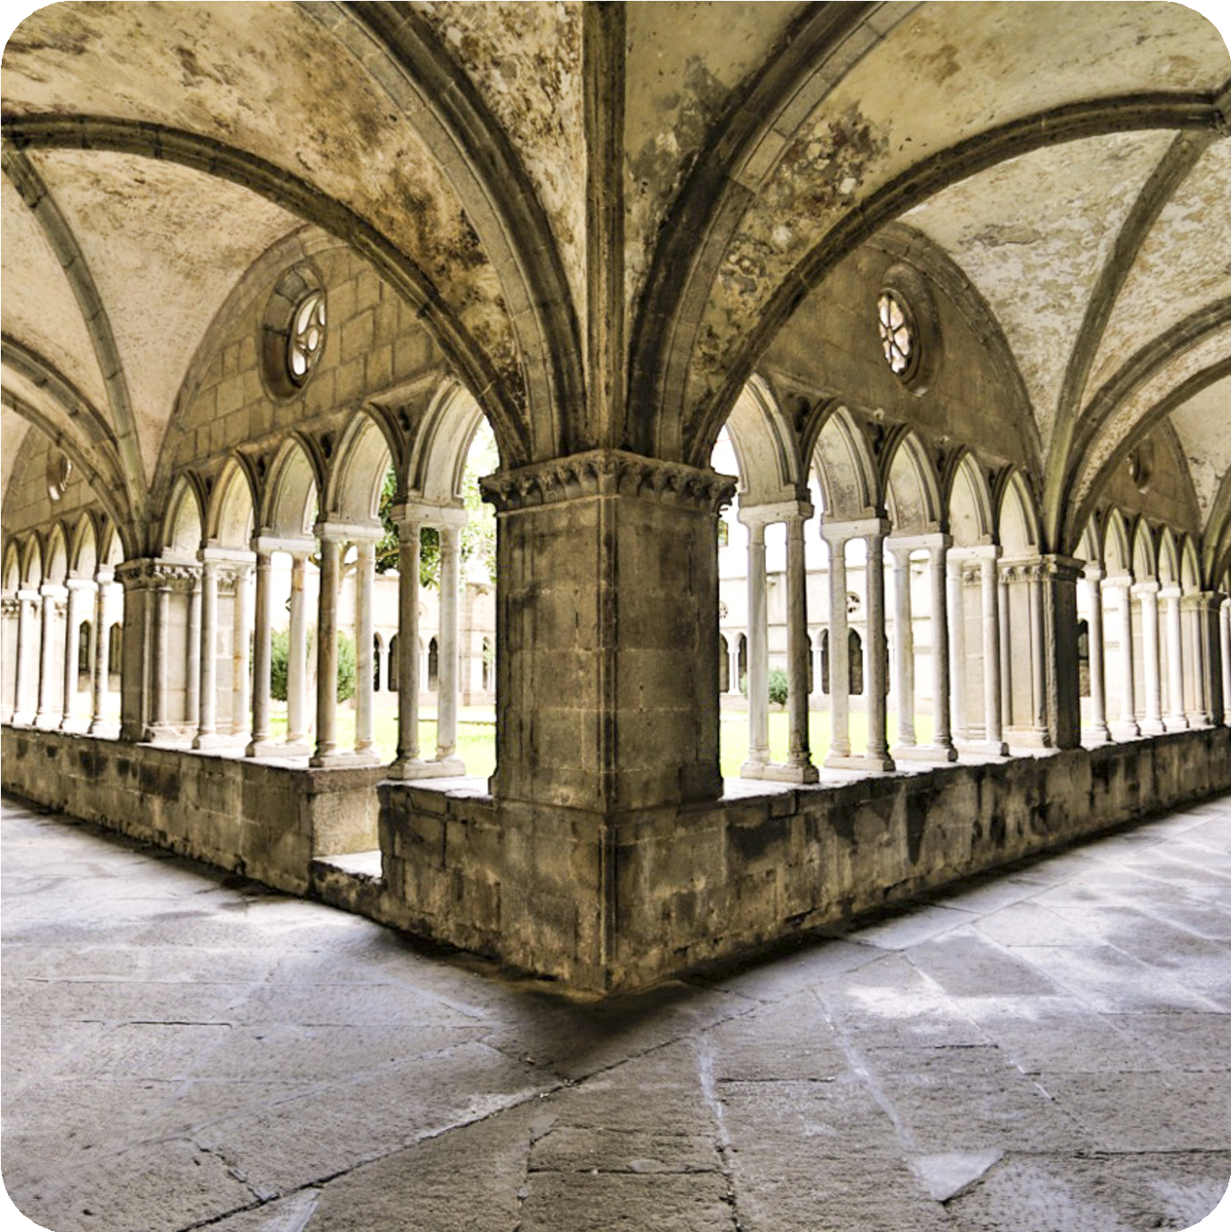

VITERBO, MAY 28-30, 2026

The Association of Italian-Canadian Writers (AICW), in collaboration with the Dipartimento di Studi Linguistico-letterari, Storico-filosofici e Giuridici (DISTU) is accepting proposals for its 20th Biennial Conference to be held at the Università degli studi della Tuscia, Viterbo, May 28-30, 2026. The conference invites academic papers, literary readings (poetry, prose or plays) and artistic works in Italian-Canadian and Italian literature and culture that engage with the following possible topics:

Contemporary life writing
Literary, cultural and linguistic memory writing
Representations of place, space, and (dis)location Current trends in contemporary media
Food Culture Visual Culture
Representations of queerness Gender and Sexuality
Urban landscapes
Translation and self-translation Intersections of cultures
The relationship between journalism and literature The writer’s civic duty
The relationship between literature and industry Italian and Italian-Canadian history

Other topics not mentioned above will also be taken into consideration.

Writers, artists, academics and researchers from all disciplines can submit proposals in Italian, English or French.
Graduate students and emerging writers are encouraged to participate. Academic papers will be allotted 20 minutes.
Creative writing readings will be allotted 15 minutes.
For individual papers: please send a 200-word abstract and short bio (60 words). For panels:
Academic papers: three papers of 20 minutes each, send a 200-word abstract for each paper as well as a short bio (60 words) and contact information for all panelists.
Creative writing: four readings of 20 minutes each, send a 200-word abstract for each paper as well as a short bio (60 words) and contact information for all panelists.

The deadline for all proposals is Friday, December 19, 2025. Please note that once a proposal has been accepted, a conference registration fee $100 will be requested for presenters who are not full members of the AICW in good standing.

Please send submissions and queries to: csansalone@laurentian.ca

Visit http://aicw.ca/ to find out more about the Association of Italian-Canadian Writers (AICW).

