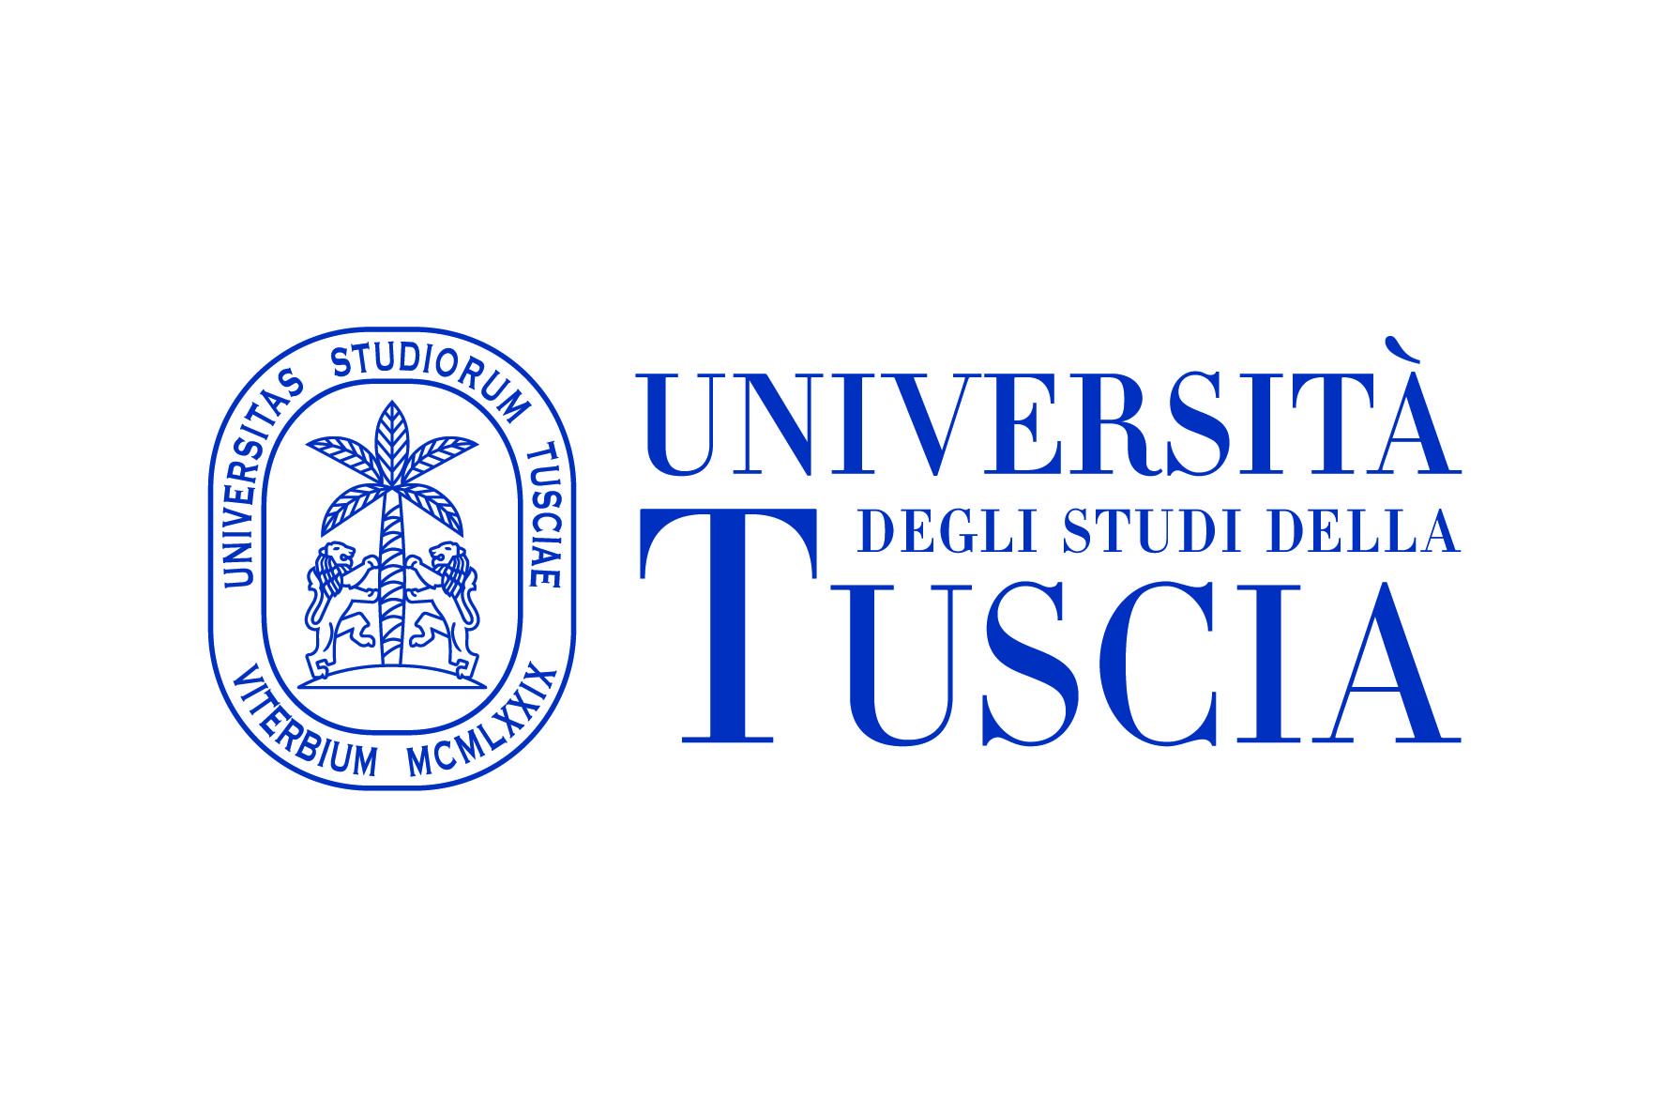
LOGO UNIVERSITY

MEMORANDUM OF COOPERATION
ON SCIENCE AND EDUCATION

BETWEEN

UNIVERSITY OF TUSCIA
ITALY

AND

Name of the University/Institution

The University of Tuscia, based in via S. Maria in Gradi 4, 01100 Viterbo, Italia, represented by its Rector, Prof. Stefano Ubertini, and the ……….……(name and official address of the University/Institution), based in (official address) represented by its Rector, Professor , and hereinafter referred to as Parties,
intending to strengthen cooperation in the field of science, technology and education,
acknowledging importance of partnership based on the principles of voluntary participation, equality, common good and reciprocity,
subject to the availability of resources provided to fulfill cooperation between the Parties,
agreed on the following:

Article 1
Goals

Main goals of this Memorandum are:
establishment of framework for cooperation in the field of science, technology and education between the Parties;
efforts to respond to global and regional challenges through shared experience and complimentary capacities in the field of science, technology and education;
generating and sharing new knowledge and development of innovative products and services in the field of science, technology and education, subject to resources available to the Parties;
facilitating Parties’ partnership in the field of science, technology and education whenever it is appropriate.

Article 2
Areas of cooperation

2.1 Main areas of cooperation under this Memorandum include (but are not limited to) the following areas:
- Exchange of information about strategies and programs of the Parties in the field of science, technology and education;
- Visits and exchange of University teaching and administrative staff and students;
- Application of the European Credit Transfer and Accumulation System (ECTS) to facilitate the exchange of students and the recognition of educational activities carried out in the two Countries;
- Exchange of scientific and teaching materials and publications;
- To explore and promote co-operation and collaboration in the fields of teaching and research;
- Development of programmes which are mutually beneficial to both parties;
- Exchange in research: Joint programmes in research and development, including exchange of publications and reports;
- Discussion of other areas of mutual interests, including the possibility of exploring joint programmes, double degree agreements and centres of excellence;
- Mutually beneficial collaborative research and development. Any publications resulting from the collaborative research will carry the names of the team members from both institutions.

2.2 Cooperation between the two universities will be developed in the following fields:

  - A timetable for progressing developments will be agreed between the two institutions.

  - Each party assign a key contact person to be responsible for the execution of this memorandum.

- Key contact person for University of Tuscia:
- Academic coordinator: Professor…………………….phone………….., email:……………………;
- Administrative contact: Carlo Contardo, Mobility and International Cooperation Office, phone +39 0761357916, email: carlocontardo@unitus.it ;
- Key contact person for …..……………………:
- Academic coordinator: Prof………………, Phone: ………. mail :

- Administrative contact: Prof………………, Phone: ………. mail :

Article 3
Mechanisms and forms of cooperation

The main mechanism of cooperation is this Memorandum.
Parties or authorized persons are able to conclude agreements and work programs which are regulated by the articles of this Memorandum.
The following forms of cooperation are applicable under this Memorandum and agreements/work programs concluded under that framework:
- short-term exchange programs for scientists, researchers, technical experts and lecturers;
- specialized educational programs to promote human capital in the field of science, technology and education;
- joint scientific guidance for MSc and PhD students;
- organization of practical workshops, symposiums, and conferences based on common interest in the field of science, technology and education;
- exchange of information in the field of science, technology and education;
- development and implementation of joint educational programs, double degree agreements and scientific and research projects.

Article 4
Mechanisms and forms of financing

Cooperation in the field of science, technology and education in the framework of this Memorandum will be supported by appropriate mechanisms and forms of financing which are agreed on by the Parties in supplementary agreements and work programs.

The University of Tuscia might contribute to the expenses for the mobility of teaching, technical and administrative staff and the mobility of students, in compliance with the University Guidelines for International Agreements and access to mobility funds in force (D.R. n. 496/15 - 13.05.2015, D.R. n. 678/16 del 03.08.2016). If the financial resources ascribed to the Mobility and International Cooperation Office to this aim will not be available, the exchange can take place only on a personal payment base.

Article 5
Control of intellectual property rights

Both parties guarantee appropriate and effective protection and equal distribution of rights on the intellectual property which may arise as a result of joint cooperation in the framework of this Memorandum according to national laws and international agreements of the countries which the Parties belong to.
Conditions of acquisition, maintenance and use of intellectual property rights regarding the possible products and (or) processes which may be a result of this Memorandum should be a subject of supplementary agreements and work programs in the framework of cooperation.
Article 6
Gender equality
The parties declare that they know and accept the internal regulations on sexual harassment, violence and gender discrimination. The University of Tuscia follows the guidelines of the European Institute for Gender Equality (EIGE) and aims to "identify and implement innovative strategies to promote cultural change and equal opportunities in Universities and Research Centers" (http://eige.europa.eu). The University of Tuscia has developed a Gender Equality Plan on which it bases its activity (https://www.unitus.it/wp-content/uploads/2023/10/Gender-Equality-Plan_eng_compressed-1-3.pdf)

Article 7
Conclusion

The Memorandum enters into force from the date of signing and is valid within 5 (five) years. In case one of the Parties won’t inform another Party about its intention not to prolong this Memorandum, it shall be automatically extended at the end of initial term for another term of 5 (five) years.
Contents of this Memorandum may be changed by the mutual agreement between the Parties.
Any Party at any time may inform another Party about its intention to terminate this Memorandum. In this case the termination shall take effect in 6 (six) months after the date of notification and shall not include ongoing activities in the cooperation framework unless the Parties have mutually decided otherwise.
The Parties shall commit themselves to solving any dispute connected to the interpretation or implementation of this Memorandum through direct negotiations.

This Memorandum has been duly signed in 2 copies in English, all texts being equally authentic. In case of disputes on the interpretation of the Protocol, the Parties shall use the text in the English language.

For  UNIVERSITY OF TUSCIA  ______________________  Rector  Professor Stefano UBERTINI  Viterbo / /2025 | For  Name of the University  ________________________  Rector  Professor …………………..  Place and data / /2025

